Kamran Gul | CMS: 023-25-0161 | CS AI (C) | Lab # 8
Task 1:
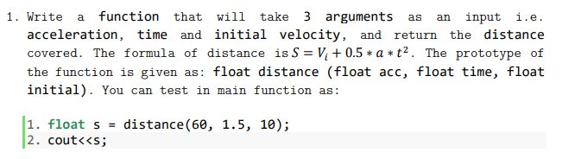
Solution:
#include <iostream>
using namespace std;
float distance(float acc, float time, float initial);

int main() {
float a,t,in;
cout<<"Enter acceleration: ";
cin>>a;
cout<<"Enter time: ";
cin>>t;
cout<<"Enter initial velocity: ";
cin>>in;

float dis = distance(a,t,in);
cout<<endl;
cout<<"Total Distance is:"<<dis;

cout<<endl;
system("PAUSE");
return 0; }

float distance(float acc, float time, float initial){
return initial+ (0.5*acc*(time*time));
}
Output:
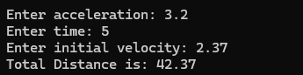
Task 2:
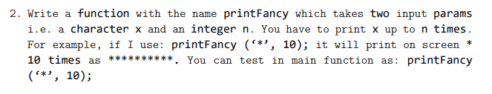
Solution:
#include <iostream>
using namespace std;
void printFancy(char x, int num);
int main() {
int n;
char x;
cout<<"Enter character you wanna print: ";
cin>>x;
cout<<"Enter how many time you wanna print: ";
cin>>n;

printFancy(x,n);

cout<<endl;
system("PAUSE");
return 0;
}
void printFancy(char x, int num){
int i=1;
while(i<= num){
cout<<x;
i++;
}
}

Output:
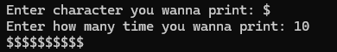

Task 3:
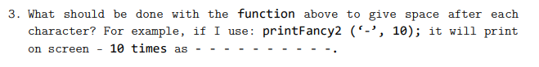
Solution:
#include <iostream>
using namespace std;
void printFancy(char x, int num);
int main() {
int n;
char x;
cout<<"Enter character you wanna print: ";
cin>>x;
cout<<"Enter how many time you wanna print: ";
cin>>n;

printFancy(x,n);

cout<<endl;
system("PAUSE");
return 0;
}
void printFancy(char x, int num){
int i=1;
while(i<= num){
cout<<x<<" ";
i++;
}
}

Output:
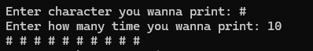

Task 4:
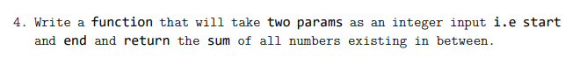
Solution:
#include <iostream>
using namespace std;
int sum(int start, int end){
int s=0;
for (int i=start+1;i<end;i++){
s +=i;
}
return s;
}
int main() {
int s,e;
cout<<"Enter start value: ";
cin>>s;
cout<<"Enter end value: ";
cin>>e;

int a =sum(s,e);
cout<<"The sum of all number between is "<<a;

cout<<endl;
system("PAUSE");
return 0;
}
Output:
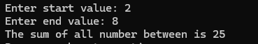

Task 5:
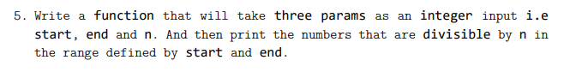
Solution:
#include <iostream>
using namespace std;
int sum(int start, int end, int n){
int s=0;
for (int i=start+1;i<end;i++){
if(i%n==0){
cout<<i<<" ";
}
}

}
int main() {
int s,e,n;
cout<<"Enter start value: ";
cin>>s;
cout<<"Enter end value: ";
cin>>e;
cout<<"Enter n: ";
cin>>n;

sum(s,e,n);

cout<<endl;
system("PAUSE");
return 0;
}
Output:
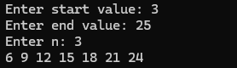

Task 6:
Solution:
#include <iostream>
using namespace std;
void swap(int x, int y){
cout<<"Before Swap"<<endl;
cout<<x<<" "<<y<<endl;
int a = x;
x = y;
y = a;

cout<<"Before Swap"<<endl;
cout<<x<<" " <<y;
}
int main() {
swap(2,5);

cout<<endl;
system("PAUSE");
return 0;
}
Output:
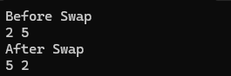

Task 7:
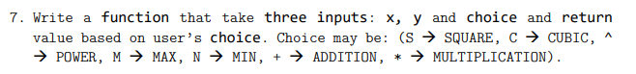
Solution:
#include <iostream>
#include<cmath>
using namespace std;
void choice(double x, double y, char c){
switch(c){
case 's':
cout<< pow(x,2) << " " << pow(y,2);
break;
case 'c':
cout<< pow(x,3) << " " << pow(y,3);
break;
case '^':
cout<< pow(x,y);
break;
case 'm':
cout<< max(x,y);
break;
case 'n':
cout<< min(x,y);
break;
case '+':
cout<< x + y;
break;
case '*':
cout<< x * y;
break;

}
}
int main() {
double a,b;
char ch;
cout<<"First Value: ";
cin>>a;
cout<<"Second Value: ";
cin>>b;
cout<<"Operation: ";
cin>>ch;

choice (a,b,ch);

cout<<endl;
system("PAUSE");
return 0;
}

Output:
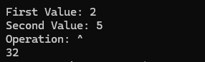

Task 8:
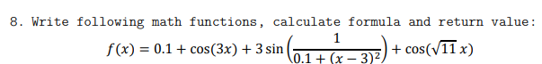
Solution:
#include <iostream>
#include<cmath>
using namespace std;

float cal(float x){
return 0.1 + cos(3*x) + 3*sin((1/0.1+pow(x-3,2))) + cos(sqrt(11)*x);
}

int main() {
float x,a;

cout<<"Enter value of x: ";
cin>>x;
a = cal(x);
cout<<a;
cout<<endl;
system("PAUSE");
return 0;
}
Output:
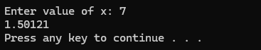

Task 9:
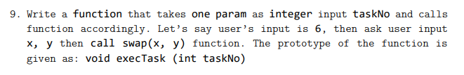
Solution:
#include<iostream>
using namespace std;

void swap(int x, int y);
void execTask(int taskNo);
int main(){

int num;
cout<<"Enter number: ";
cin>>num;

execTask(num);

cout<<endl;
system("PAUSE");
return 0;
}
void swap(int x, int y){
int a = x;
x = y;
y = a;

cout<<x<<" " <<y;
}
void execTask(int taskNo){
int x,y;

for(int i=1;i<=taskNo;i++){
cout<<"Enter x: ";
cin>>x;
cout<<"Enter y: ";
cin>>y;
swap(x,y);
cout<<endl;
}}

Output:
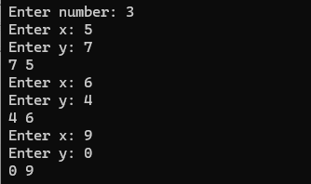

Task 10:
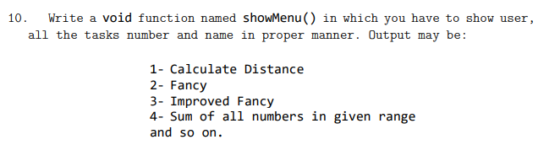
Solution:
#include<iostream>
using namespace std;

void menu(){
cout<<"1. Caluculate Distance \n2. Fancy"<<endl;
cout<<"3. Improved Fancy \n4. Sum of all numbers in range"<<endl;
}

int main(){

menu();

cout<<endl;
system("PAUSE");
return 0;
}

Output:
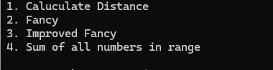

Task 11:
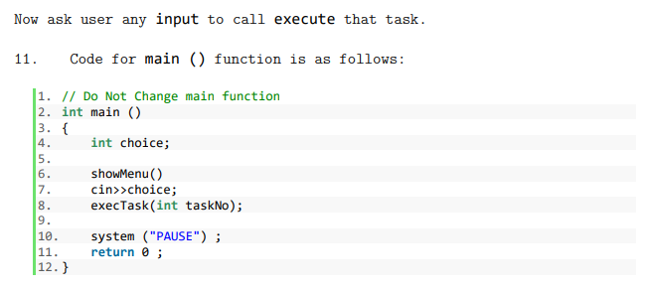

Solution:
#include<iostream>
using namespace std;

void menu(){
cout<<"1. Caluculate Distance \n2. Fancy"<<endl;
cout<<"3. Improved Fancy \n4. Sum of all numbers in range"<<endl;
}

float distance(float acc, float time, float initial){
return initial + (0.5*acc*(time*time));
}

void printFancy(char x, int num){
int i=1;
while(i<= num){
cout<<x;
i++;
}
}

void improvedFancy(char x, int num){
int i=1;
while(i<= num){
cout<<x<<" ";
i++;
}
}

int sum(int start, int end){
int s=0;
for (int i=start+1;i<end;i++){
s +=i;
}
return s;
}

void execTask(int opr){

if(opr == 1){
float a,t,in;
cout<<"Enter acceleration: ";
cin>>a;
cout<<"Enter time: ";
cin>>t;
cout<<"Enter initial velocity: ";
cin>>in;

float dis = distance(a,t,in);
cout<<endl;
cout<<"Total Distance is: "<<dis;

}
else if(opr == 2){
int n;
char x;
cout<<"Enter character you wanna print: ";
cin>>x;
cout<<"Enter how many time you wanna print: ";
cin>>n;

printFancy(x,n);

}
else if(opr == 3){
int n;
char x;
cout<<"Enter character you wanna print: ";
cin>>x;
cout<<"Enter how many time you wanna print: ";
cin>>n;

improvedFancy(x,n);

}
else if(opr == 4){
int s,e;
cout<<"Enter start value: ";
cin>>s;
cout<<"Enter end value: ";
cin>>e;

int a =sum(s,e);
cout<<"The sum of all number between is "<<a;
}
else
cout<<"Wrong Entry!!!";
}

int main(){
int choice;
menu();

cout<<"Enter Number of Operation you wanna perform: ";
cin>>choice;
cout<<endl;
execTask(choice);

cout<<endl;
system("PAUSE");
return 0;
}
Output:
